Coming, Katelyn L.

IT26A

Insert Command:

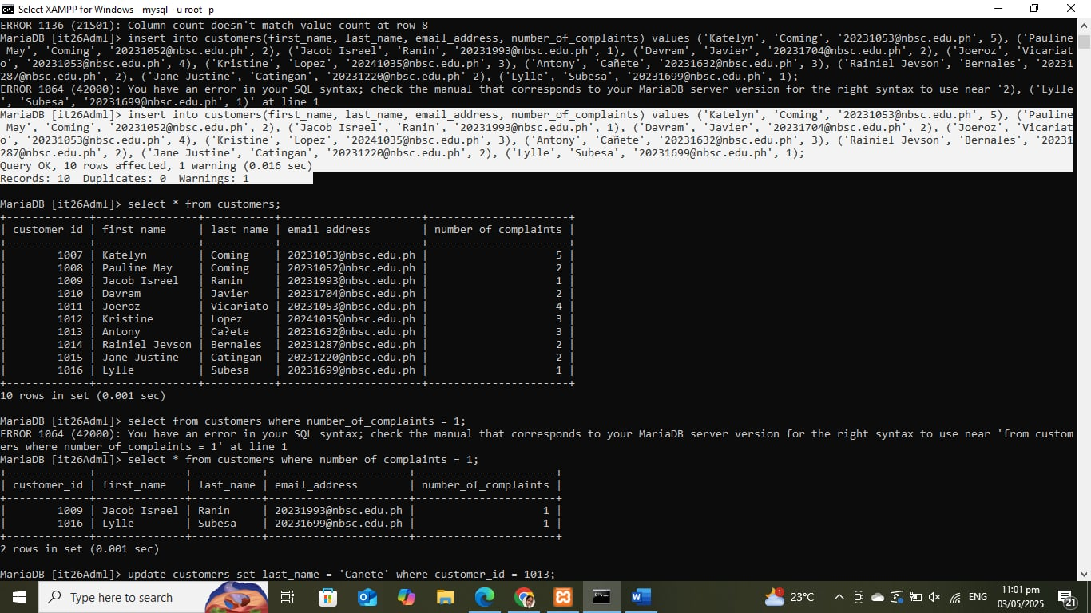

Select Command:

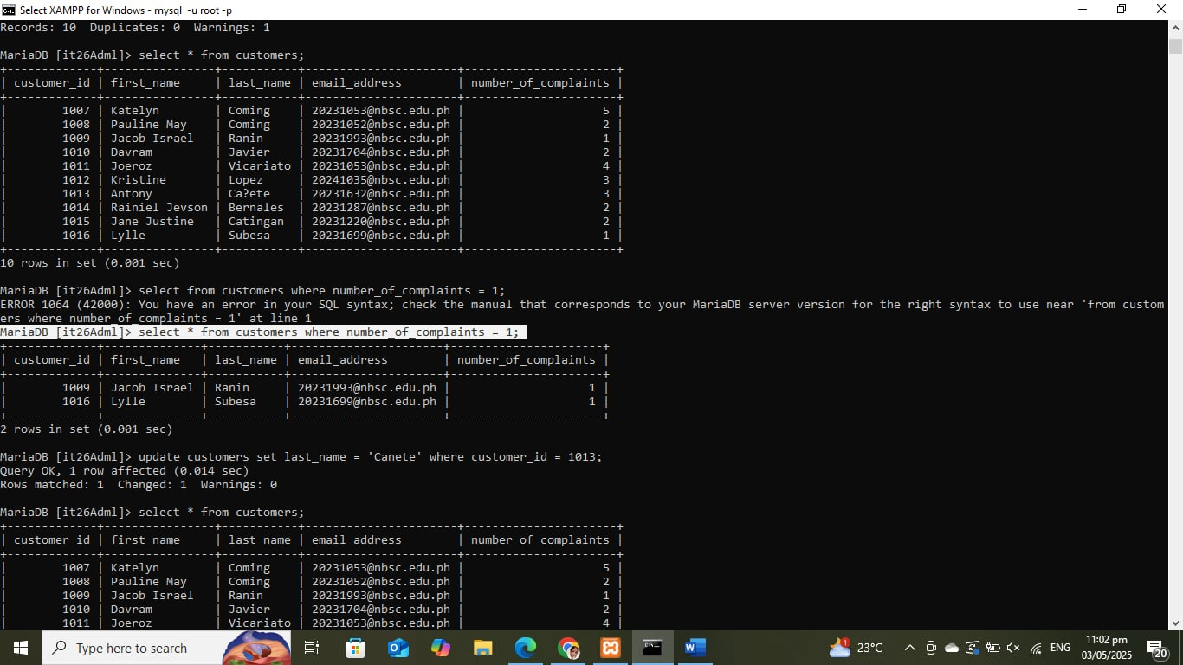

Update Command:

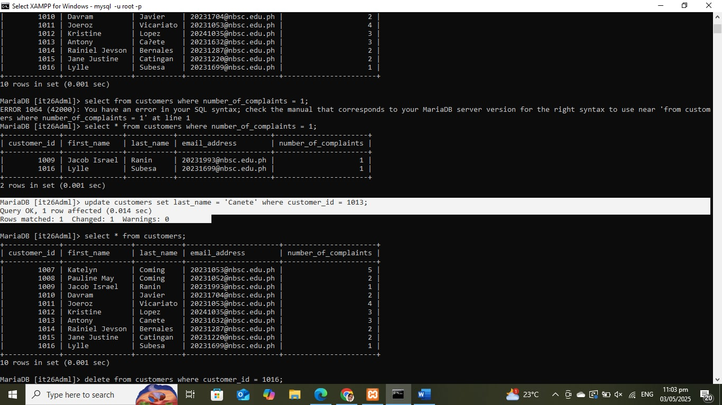

Delete Command:

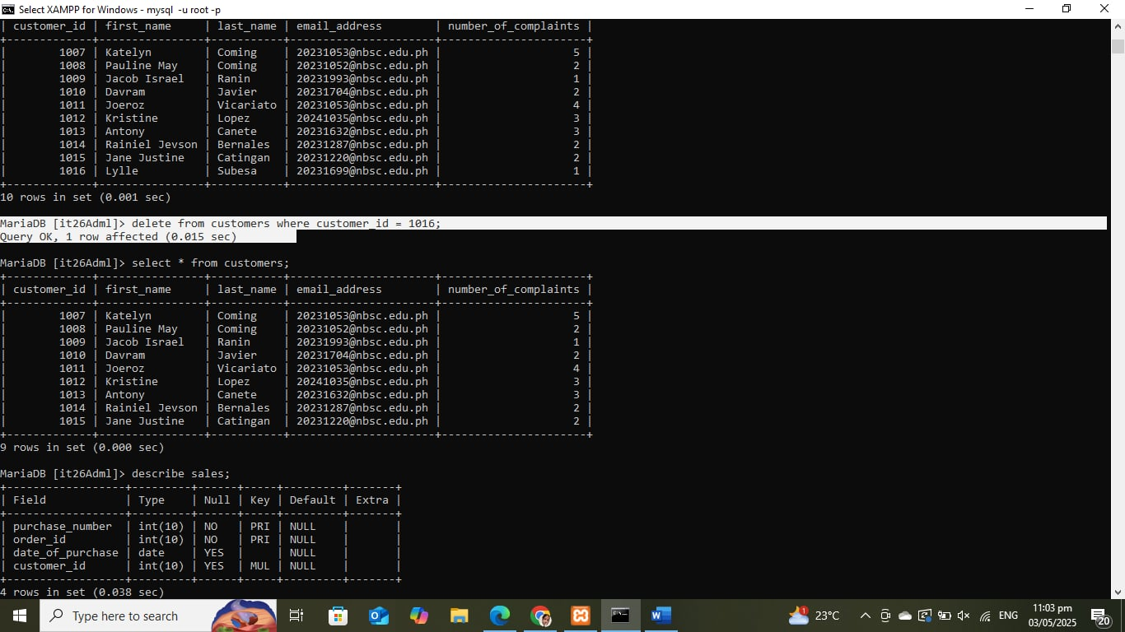

Cascade Command:

Ma’am, I haven't performed a cascading command because it was already set up in the database. As a result, when I delete/update a row from the parent table (customers), the corresponding rows in the child table (sales) are automatically removed/updated.

